CSA1701-ARTIFICIAL INTELLIGENCE

NAME:P HARISH
REG NO:192524197
VACUUM CLEANER PROBLEM
Aim:
To write a Python program to implement the Vacuum Cleaner Problem using a simple agent-based approach.
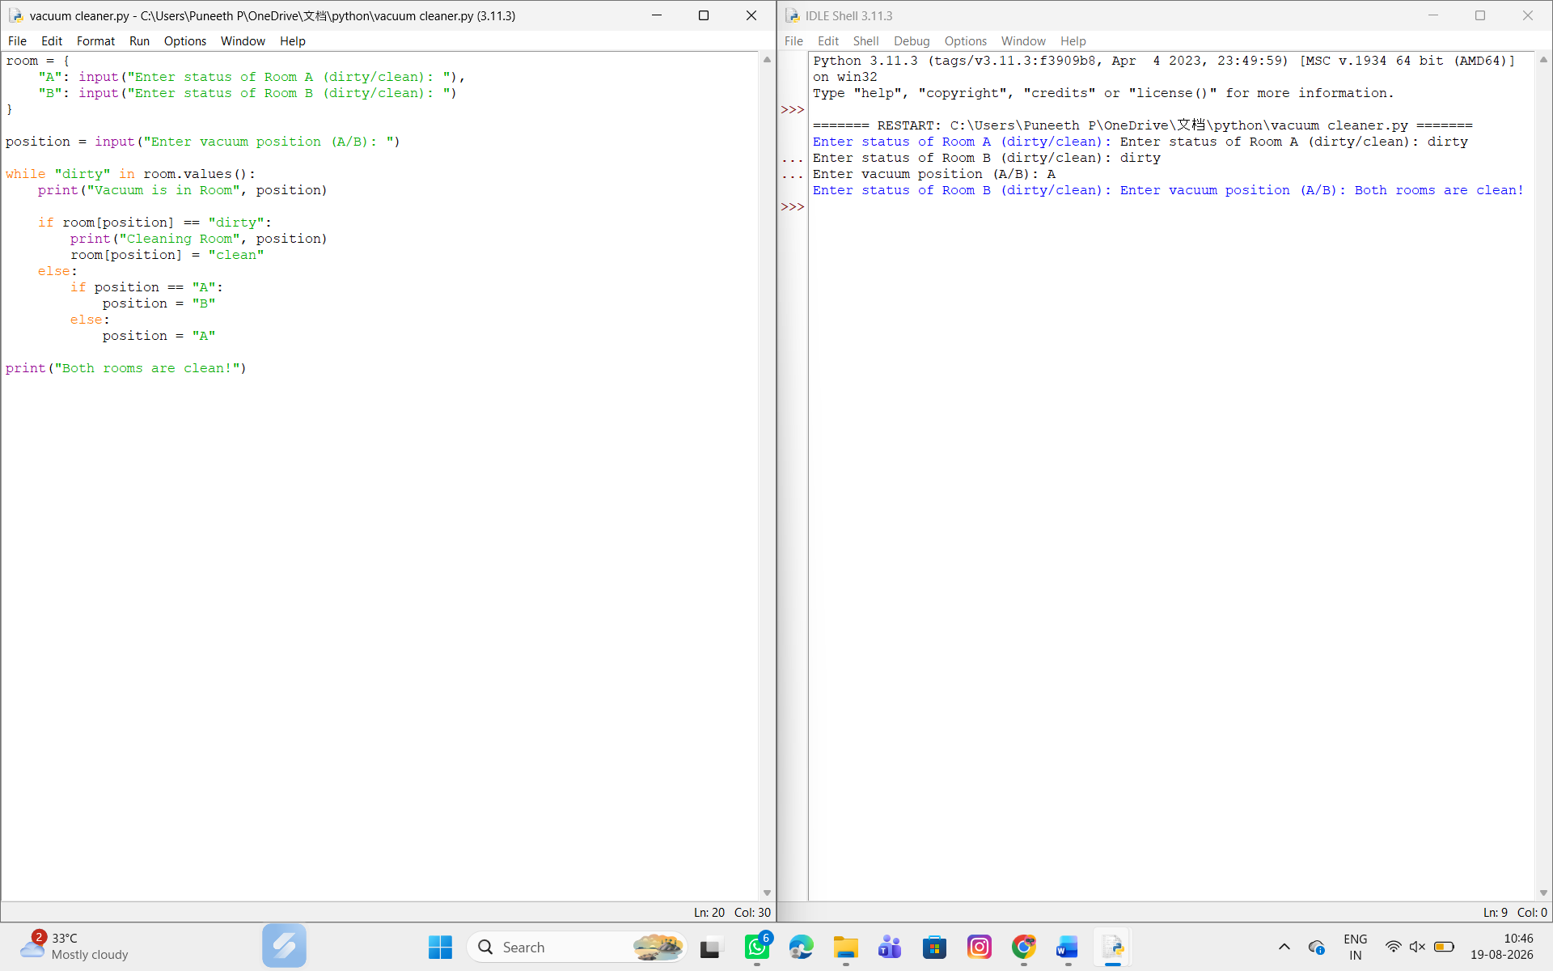

Result:
Thus, the Vacuum Cleaner Problem was successfully implemented using Python.

